Apelon DTS Installation Instructions for Windows

Last updated 2010-10-19

Authors: David Shields, Guilherme Del Fiol, Ken Kawamoto

Note: these instructions require a SQL Server installation being available

Apelon DTS

Download DTS 3.5 (this example used dts_3.5.0.132) from http://apelon-dts.sourceforge.net/

Download the Quick Start guide from http://apelon-dts.sourceforge.net/3.5/docs/dtsquickstart.pdf. These instructions are based on the Quick Start Guide.

Install Apelon DTS using default options, except for choosing MS SQL Server with the Microsoft JDBC driver as the database

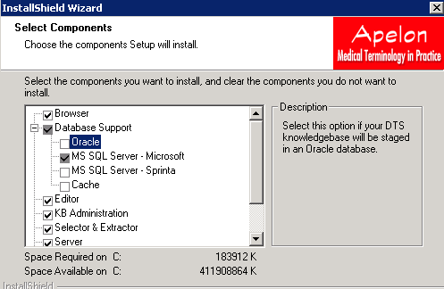

Create SQL Server Database File

NOTE: do NOT modify the drivers.xml file as noted in the quick start guide unless multiple databases/drivers have been selected

If using SQL Server 2008, download the JDBC driver for SQL Server 2008 by going to http://www.microsoft.com/downloads/details.aspx?FamilyID=a737000d-68d0-4531-b65d-da0f2a735707&displaylang=en

Copy the sqljdbc.jar and replace the jar in the following directory: DRIVE:\Program Files\Apelon\DTS 3.5\lib

SQL Server Configuration Manager → set TCP/IP port to 1433

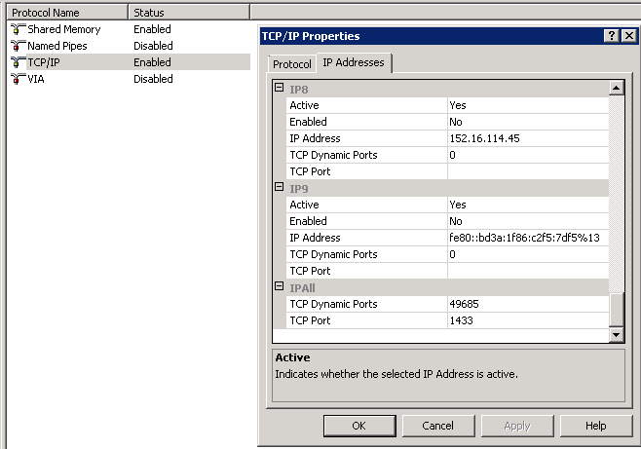

Create a SQL Server database using the SQL Server Management Studio, with a SQL Server login/password with administrative privileges. NOTE: there is a script located at DTSInstall\ Apelon\DTS 3.5\scripts\SQL2K called userCreate.bat that automate the database and user creation process. The Quick Start Guide talks about this script only within the context of Oracle. We created the database and user manually, but most likely the script would have been a better option. To run the script, make sure that : 1) the latest SQL Server JDBC driver is downloaded as described above; 2) SQL server is setup for SQL server and Windows authentication mode; and 3) SQL server is setup for compatibility level SQL Server 2000 (80).

A recommended name for the DB is “dts”

For convenience, in this example, setting initial DB size to 2000 MB

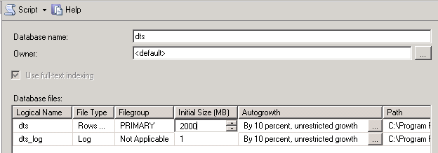

SQL server user creation

Security → Logins

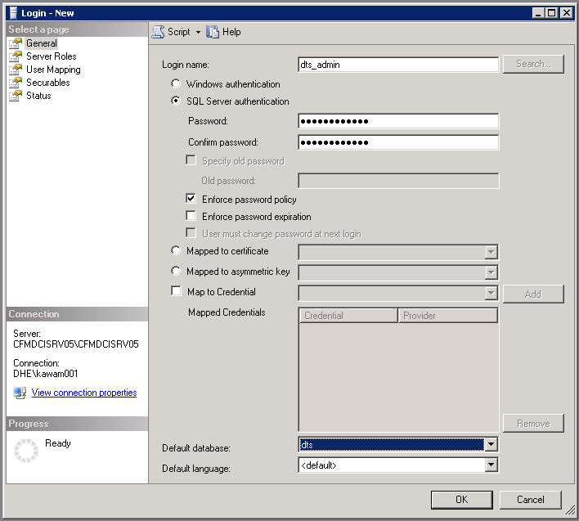

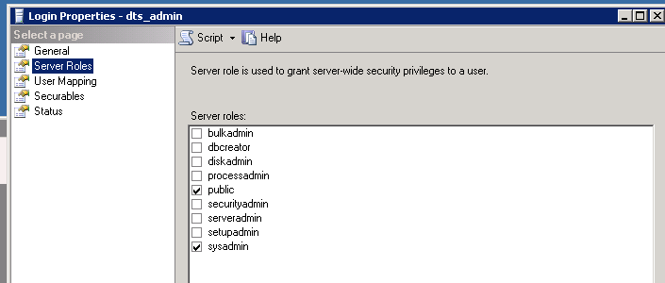

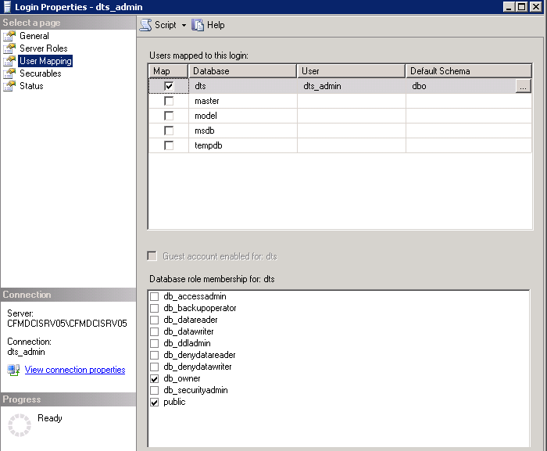

Under database (e.g., dts) → Security → Users → select user created, make db_owner

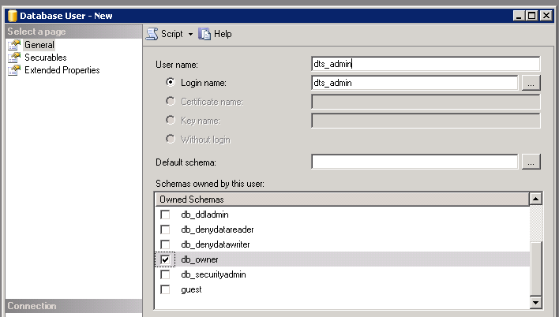

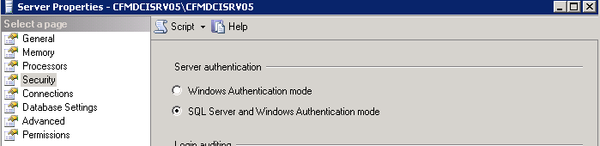

As noted above, make sure server is set up to have SQL Server and Windows Authentications mode

Create DTS Knowledgebase Schema

Edit kbcreate.xml at DTSInstall\bin\kb\create

Comment out oracle driver, comment in Microsoft Driver

Change user and pass – make sure to use a user with SQL server authentication and not windows authentication

Edit kbcreate.bat (DTSInstall\bin\kb\create) so the start sequence is 2000000001 (note there are more 0’s than this in the default). This configuration makes this installation a “source custom” database.

Set username / password to access dts database in DTSInstall\Apelon\DTS 3.5\bin\kb\target-connection.xml (may not be necessary if the database and user were created through the createUser.bat script)

Run kbcreate.bat

==== CREATE USERS ======

See “Create DTS users” section of Quick Start Guide

When connecting to dts, click on “Advanced” to set database name to "dts"

Was able to create user following instructions in the Quick Start Guide, but not able to set permissions until namespaces are created by populating the knowledgebase tables (next Section in the Quick Start Guide)

==== Populate DTS Knowledgebase tables ====

Download content files from Apelon Web site (member area)

Followed instructions under Section "Perform Full Import Using the DTS Subscription Import Wizard" in the Quick Start Guide

Performed full import for terminologies available on-by-one (can import all at once though): ICD9, CPT, LOINC, RxNorm, SNOMED-CT

Performed full-import of mappings: ICD9-SNOMED-CT and CPT-SNOMED-CT

Demo

Verify installation by going to \\[machine name –e.g., CFMDCISRV05]:8080/dtstreebrowser/ and login exactly as shown below

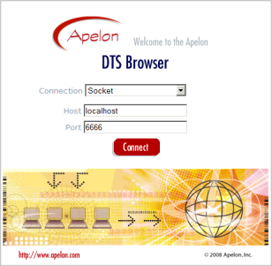

Installation notes

I installed the base Apelon DTS package on my local machine, using all the defaults from http://apelon-dts.sourceforge.net/download.html#DTS%20Downloads

I considered installing it on cfmdcitest, but decided to do it on my machine first.

Installation requires that you choose a database, from the list above. I chose Oracle (which was the default).

I installed Oracle 10g Express Edition on my local machine from http://www.oracle.com/technology/software/products/database/xe/htdocs/102xewinsoft.html using all the defaults, except that I changed the port for the administration server which runs under Tomcat to use port 8081 so that it wouldn’t clash with Sebastian.

I modified the script at C:\Program Files\Apelon\DTS 3.5\scripts\Oracle\userCreateDefaults.bat to point to my C:\ drive instead of a D:\ drive, since I don’t have a D:\ drive.

I modified the script at C:\Program Files\Apelon\DTS 3.5\scripts\Oracle\userCreate.bat to hard-code the path to sqlplus as C:\oraclexe\app\oracle\product\10.2.0\server\BIN\sqlplus because (although oracle setup added the path to my paths statement) the command prompt couldn’t find sqlplus, and I didn’t want to restart.

I then ran userCreate.bat, which created a user named dts and a tablespace also named dts.

I modified the xml file at C:\Program Files\Apelon\DTS 3.5\bin\kb\create\kbcreate.xml to change “ORCL” to “XE”, which is something you will have to do in any setting which references the Oracle Express database server.

<!-- <property name="databaseName" value="ORCL"/> -->

to <property name="databaseName" value="XE"/>

I then modified kbcreate.bat from the same directory to remove "-t kb/target-connection.xml" from the end of the “call runApp…” line, and ran kbcreate.bat, which created the table structure in the Oracle database named dts.

Note: this step was reverted to the original when I ran the Cache database load, because the correct settings for Cache were already in place as defaults.

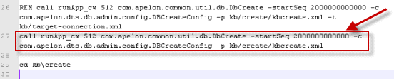

You should be able to view this database in a database tool such as Aquadata Studio with something similar to the following setup:

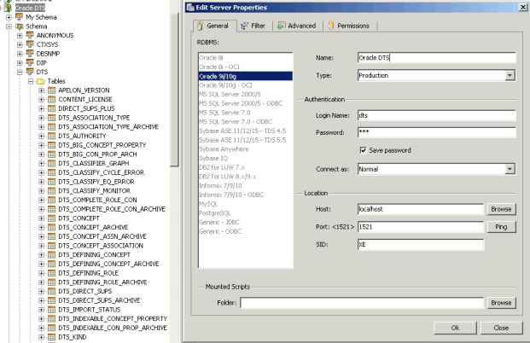

Modify C:\Program Files\Apelon\DTS 3.5\bin\server\apelonserverprops.xml to change “databaseName value=”ORCL” to “XE”

Modify C:\Program Files\Apelon\DTS 3.5\tomcat\conf\server.xml to change all ‘port=”8nnn”’ to ‘port=”18nnn” ‘ to avoid conflict with both Oracle XE and Sebastian.

Modify C:\Documents and Settings\All Users\Start Menu\Programs\Apelon\DTS 3.5 \ Apelon DTS Browser (shortcut to a URL) and right-click to modify the properties. Change the port in the URL to match what you created in the previous step, e.g.:

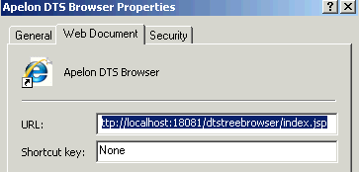

You are ready to use DTS

Go to windows program start menu / apelon/ dts 3.5 / “start Tomcat” and it should succeed, opening a command prompt and leaving it open, something like this:

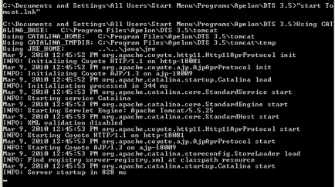

Start Apelon Server by going to Windows Start / all Programs / Apelon / DTS 3.5 / Start Apelon DTS Server, and you should get a command windows which remains open and looks somewhat like this:

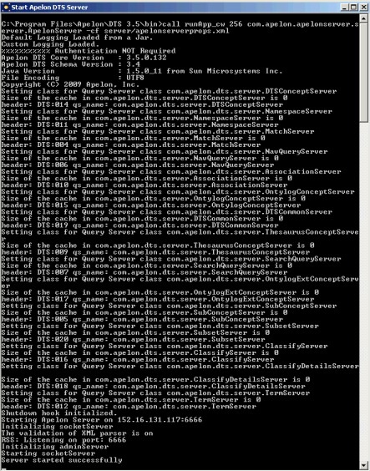

Load the Sample Data using the Apelon menu “Subscription Import Wizard, which will give you screens like the following where you select the sample data from wherever you unzipped it:

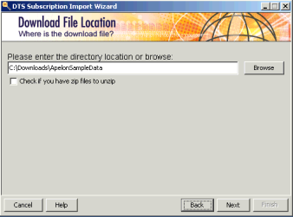

Followed by clicking every checkbox in the following screen

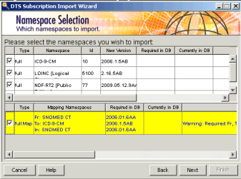

And you eventually get to the following screen where you change the selection to Import Namespaces and Mappings

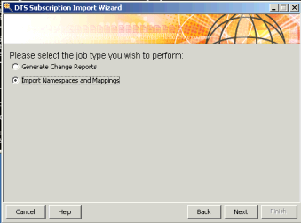

At this point, you should be able to execute Windows Start / all Programs / Apelon / DTS 3.5 / Apelon DTS Editor, and get this:

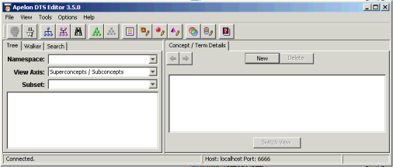

Alternatively, you should be able to execute Windows Start / all Programs / Apelon / DTS 3.5 / Apelon DTS Browser. It should open a login windows like the following. Fill in the Host and Port 6666(port 6666 is the default), and you are good to go:

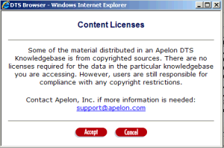

Other Notes

DTS allows you to add local concept namespaces, such as those we use for DUHS labs, etc., and has tools to relate them to standard concept namespaces. Those tools are pretty much automated, but invoking them is not. There are many options and choices to configure…

Research into Apelon and Multum (Stage Two)

Will attempt to load all or part of UMLS into Apelon, and see if I can access Multum. However, I am beginning to think Multum and Apelon are redundant concepts, with Apelon totally encompassing the vocabulary in Multum, and linking it dynamically to other Drug Vocabularies.

Multum, on the other hand, is limited to primarily Drugs (with a few major exceptions, such as Herbals and Supplements, and a few other minor exceptions).

The interesting question is whether we can query an NDC code, and cross-reference it to the Multum Drug “Class” for that Drug, or to the First Databank Drug “Class”

Download Sample Apelon Data at http://support.apelon.com/DTSContent/users/user_area.asp? (you will have to register as a user, which is quick)

ICD9CM

LOINC

NDF-RT

SNOMED-CT

SNOMED-CT to ICD9CM Mappings

Loaded Data following instructions, and the load bombed, indicating that it exceeded 4 GB of size while loading SNOMED-CT

Reconfiguring Apelon DTS to use Intersystems Cache

I downloaded and installed Cache from their demo website at http://download.intersystems.com/download/download.csp

I configured Aqua Data Studio to talk to Cache using the following Server Registration:

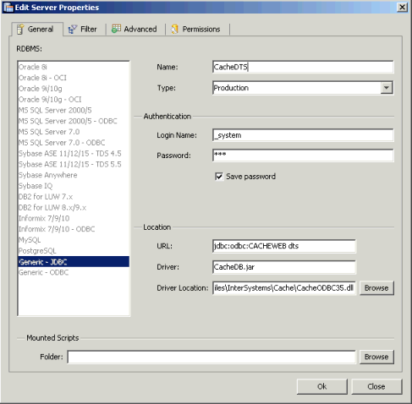

I ran the Cache Administration screen at http://localhost:57772/csp/sys/UtilHome.csp?$NAMESPACE=DTS to setup namespace DTS, and local database dts

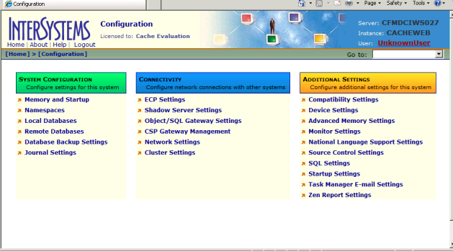

Then I went to the security management to create a role for DTS and a user dts

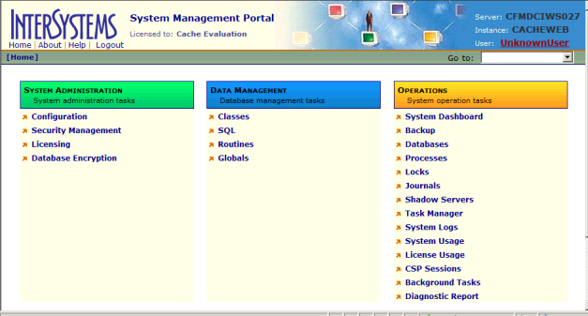

The above screens are pretty easy to use…

I copied the existing DTS directory at C:\Program Files\Apelon\DTS 3.5\ to a new one at C:\Program Files\Apelon\DTS 3.5 Cache\

I downloaded the Linux – Cache version, to examine their setup files, and to compare the downloads and installed it at C:\Program Files\Apelon\DTS 3.5 Linux\

This gave me the ability to compare the windows-oracle installation against the linux-cache installation in order to produce a windows-cache installation

I ran Altova DiffDog to compare the DTS 3.5 directory (Windows-Oracle, running) to the DTS 3.5 Linux directory (Linux-Cache)

There were no differences in the basic java / html / jpeg / gif files which comprise the DTS software

Where there were differences, they fell into two distinct groups

.bat vs .sh files

These were not significant

All of the .bat files in windows were replaced by .sh files in Linux, with similar content to accomplish exactly the same result in DTS

All of the .bat files in DTS:Tomcat were replaced by .sh files in the Tomcat settings

There were differences in some of the settings files (xml, prop, and txt files), and those differences represented the Oracle settings vs the Cache settings

DTS files specifically:

Bin\kb\create\kbcreate.xml

contains code to load sample data into Oracle, Sql-Server and Cache.

The files were the same except for what was commented out. In both cases what was left pointed to the particular database in use

Bin\kb\kbimportwizard.xml

While these files were not identical, their logical content was identical, except that the windows-oracle version had been modified by the installation script.

I assume that the linux-cache installation script would have done the same type of thing, but I didn’t run it.

Bin\kb\target-connection.xml

The linux-cache version contains parameters pointing to the Cache database

The windows-oracle version contains parameters pointing to the oracle database

Bin\kb\kbcontent-ora.xml vs bin\kb\kbcontent-cache.xml vs bin\kb\kbcontent-sql2k.xml

These three files were identical between windows-oracle and linux-cache

Bin\server\apelonserverprops.xml

The linux-cache version configured for cache

The windows-oracle version configured for oracle

Bin\drivers.xml

The linux-cache version configured only for cache

The windows-oracle version contained config for oracle and 3 versions of sql-server, all but oracle commented out

DTS Tomcat files specifically:

Tomcat\bin\drivers.xml

Same as DTS\bin\drivers.xml file above

Tomcat\conf\server.xml

I had modified windows-oracle to avoid port # collisions with Sebastian, and those modifications were the only differences.

Files present in one installation and not the other (other than .bat/.sh files with same root name)

Windows-oracle but not in linux-cache

Bin\acp.bat

Bin\ajc.bat

Bin\ajwc.bat

Bin\HTExample.ser

Bin\runApp.bat

Windows specific - keep

Bin\runApp_cw.bat

Windows specific - keep

Bin\wrapper.exe

Seems to be used if you want to wrap DTS in your own java code, ignore ???

Bin\data\*

Empty directory, ignore

Bin\editor\*

???

Bin\logs\*

Was auto created during runs, ignore

Bin\selext\selextconnection.xml

File present in lower level directory on linux, and points to oracle

Note: Linux-cache does not have a selectconnection.xml file pointing to cache

Conf\wrapper.conf

Configuration for bin\wrapper.exe, ignore ???

Icons\*

Ignore

Java\*

Ignore

Lib\ojdbc14.jar

??? might need it, but I think CacheDB.jar contains everything we need

Lib\wrapper.dll

??? Windows specific, ignore

Lib\wrapper.jar

??? Windows specific, ignore

Plugins\*

Optional source code, ignore

Samples\*

Optional source code, ignore

Scripts\Oracle\*

Windows-oracle version contained sub-directory Oracle with a bunch of oracle-specific scripts

Tomcat\common\endorsed\*

Empty directory, ignore

Tomcat\conf\Cataline\*

Empty directory, ignore

Tomcat\logs\*

Generated files, ignore

Tomcat\server\classes\*

Empty directory, ignore

Tomcat\shared\classes\*

Empty directory, ignore

Tomcat\shared\lib\odbc14.jar

Probably replaced by CacheDB.jar from linux-cache: remove or ignore???

Tomcat\webapps\dtstreebrowser\*

Generated directory and contents from dtstreebrowser.war, ignore

Tomcat\work\*

Generated by tomcat deployment of dtstreebrowser.war, ignore

Linux-cache but not in windows-oracle

Bin\makeScriptsExecutable.sh

Not needed in windows

Bin\selext\selextconnection\ *

Bin\selext\selextconnection\oracle\selextconnection.xml

Bin\selext\selextconnection\sql2k-microsoft\selextconnection.xml

Bin\selext\selextconnection\sql2k-sprinta\selextconnection.xml

3 selextconnection.xml files present in lower level directory on linux, and the one in the oracle directory matches the file at bin\selext\selextconnection.xml in windows-oracle

Note: Linux-cache does not have a selectconnection.xml file pointing to cache

Bin\server\ShutdownApelonServer.sh

No corresponding windows file ???

Bin\server\StatusApelonServer.sh

No corresponding windows file ???

Lib\CacheDB.jar

Lib\servlet.jar

Lib\struts.jar

Lib\strutscommon.jar

Above 4 files not in windows-oracle, probably needed for Cache

Scripts\Cache\*

Linux-cache version contained sub-directory Cache with one script

Tomcat\drivers.xml

Duplicate of tomcat\bin\drivers.xml, ignore

Tomcat\shared\lib\CacheDB.jar

Needed for Cache

I copied the Cache specific files identified in the 2nd group above from the linux-cache installation to the new windows-cache installation at C:\Program Files\Apelon\DTS 3.5 Cache\ to create a DTS installation set which pointed to the Cache database.

Bin\kb\create\kbcreate.xml

Bin\kb\target-connection.xml

Bin\server\apelonserverprops.xml

Bin\drivers.xml

Tomcat\bin\drivers.xml

Tomcat\conf\server.xml

No! This file needs to remain with the same modifications originally used for Oracle and described above.

I dealt with files present in one installation but not the other by modifying DTS 3.5 Cache as follows:

Copied following files from linux-cache to windows-cache

Lib\CacheDB.jar

Lib\servlet.jar

Lib\struts.jar

Lib\strutscommon.jar

scripts\Cache\*.*

tomcat\shared\lib\CacheDB.jar

Removed following files from windows-cache:

scripts\Oracle\*.*

tomcat\shared\lib\odbc14.jar

Need to hand-modify bin\selext\selextconnection.xml in windows-cache to point to Cache instead of Oracle, in the same way as configuration from bin\kb\target-connection.xml

Following lines inserted and oracle section commented out

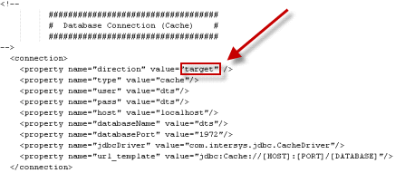

Need to hand-modify bin\kb\source-connection.xml to match bin\kb\target-connection.xml

Following lines inserted and oracle section commented out

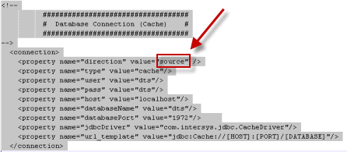

Need to hand-modify bin\kb\kbimportwizard.xml to match bin\kb\target-connection.xml

Following lines inserted and oracle section commented out

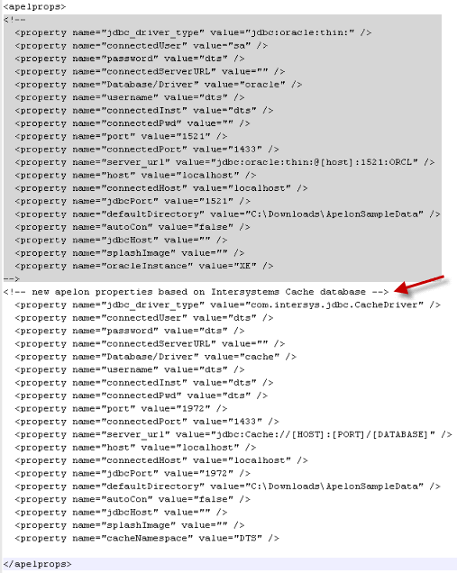

I then renamed DTS 3.5 as DTS 3.5 Oracle, and renamed DTS 3.5 Cache as DTS 3.5, so that I ended up with the following directories:

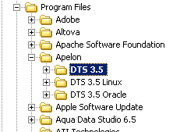

This allowed me to keep the existing entries in my start menu, and the windows registry (except that I don’t think the DTS installer made any entries in the registry…)

For backup, I zipped the DTS 3.5 Cache installation set into a file, and stored it on the network at \\cfmsrv1\administration\Products\TerminologyServices\Apelon\DTS\DTS 3.5 Cache\DTS 3.5 Cache.zip along with a readme file

I ran kbcreate, just like I had done for the initial installation on Oracle.

This bombed off after completing most of the table creation on an SQL error on table SEARCH_INDEX

I posted a question about the error to the Apelon DTS listServe, and received a response to create the database directly from SQL

This seems something related to newer version of Cache.
Here is a workaround for this.

You can run this SQL statement under the Cache Management Console > Home > SQL > Execute SQL Query (with “Cache Namespace” for DTS selected).

CREATE TABLE SEARCH_INDEX
(
id NUMERIC(38,0) NOT NULL,
con NUMERIC(38,0) NOT NULL,
val VARCHAR(512) COLLATE %EXACT,
NAMESPACE_ID INTEGER NOT NULL
)

After this run KBCreate.bat again and you will get this message -

Some tables exist and there are new tables to install.
Would you like to add new tables or
or drop and recreate all the tables?

Enter 'add' to add only new tables.
Enter 'drop' to drop and recreate all tables.
Enter 'view' to view new tables.
Enter 'q' to quit the application.

Please enter 'add', 'drop', 'view' or 'q':

Enter “add” .
This will create the rest of the tables.

I followed the above instructions and reran kbcreate, which then completed successfully.

I ran Apelon \ DTS 3.5 \ Subscription Import Wizard

This informed me that I needed to rerun kbcreate

I looked at the database schema for Cache-DTS, and there were tables missing when compared to the Oracle-DTS schema. Furthermore, there were indexes and constraints on SEARCH_INDEX that had not been created.

I tried to create the indexes manually, and was able to create the indexes, but they didn’t show in either Cache Management Studio, or in Aquadata Studio.

I tried to create the constraints, but the table pointed to by the first constraint in Oracle did not exist in Cache, and the second constraint would not install for what the error message said was the same reason, although the table pointed to by the second constraint *did* exist in Cache.

I posted another question to the Apelon DTS listServe

At this point I am abandoning Cache, unless I get some help from Apelon or Cache on the configuration issues.

I think it might be due to the 2010.1 version of Cache not yet being supported by DTS…

Starting over with Micosoft Windows-SqlServer…

Installed from the download, installation worked.

Tried kbcreate and I get SQL error.

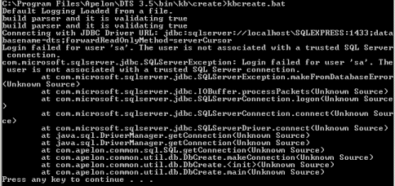

I tried making sure the server supported both windows and SQL Server authentication, I added password to SA account. Spent hours on google, no joy…

Sql error is fixed by

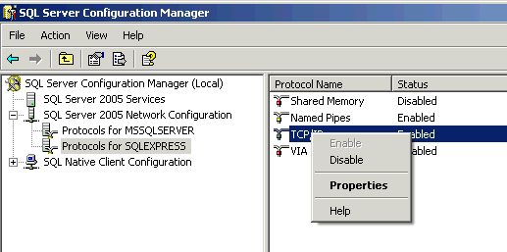

Make sure the TCP Dynamic Ports is blank, and TCP Port is set to 1433

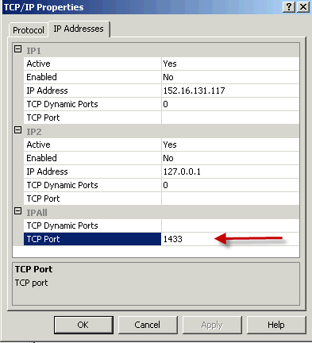

Now kbcreate.bat loads…

View the kbcreate log at C:\Program Files\Apelon\DTS 3.5\bin\logs\kbcreate.og

Load the Sample Database

Choose Apelon “Subscription Import Wizard” from the windows Start menu

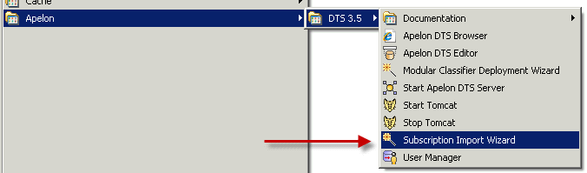

It opens this window, use the settings shown, with password ‘a091001’

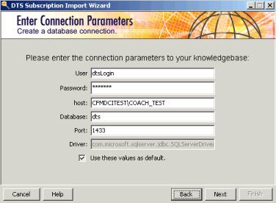

Click ‘Next’ and you get this

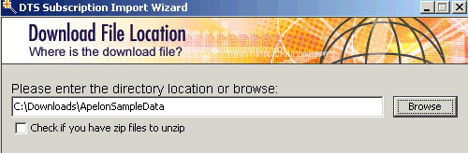

I had previously unzipped ApelonSampleData into the directory shown above. You could alternatively select the zip file and turn on the checkbox…

Click ‘Next’ and you get this

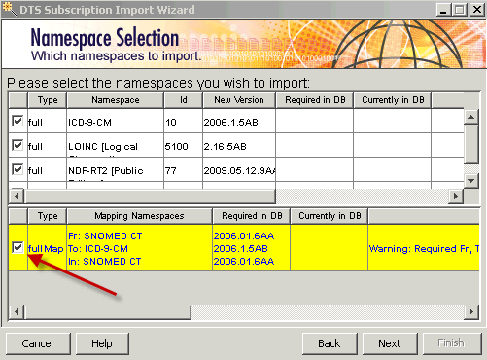

Click the checkbox beside ‘fullMap’ in the bottom section, and that section will turn yellow, indicating that it has a dependency on the successful completion of one of the above namespace imports

Click ‘Next’ and you get the same screen back as a confirmation. Click ‘Next’ again after review and you get this

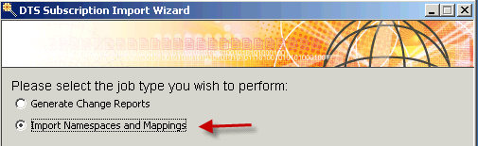

Make sure to select “Import Namespaces…” as shown above

Click ‘Next’ and the import will start…

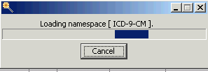

It will cycle through all the Namespaces you selected

This may take several hours, because it is loading all of SNOMED-CT and NDF-RT, and cross-indexing everything…

View the import log at C:\Program Files\Apelon\DTS 3.5\bin\logs\kbContent.og

Configure Apelon DTS 3.5 for MS SQL Server

Modify C:\Program Files\Apelon\DTS 3.5\bin\server\apelonserverprops.xml to following

<property name="user" value="dtsLogin" />

<property name="pass" value="a091001" />

<property name="host" value="CFMDCITEST\COACH_TEST" />

Modify C:\Program Files\Apelon\DTS 3.5\tomcat\conf\server.xml to change all ‘port=”8nnn”’ to ‘port=”38nnn” ‘ to avoid conflict with Oracle XE (which I had installed as 18nnn), Cache (which I had installed as 28nnn), Sql Server Express (which I had installed as 48nnn), and Sebastian.

Modify C:\Documents and Settings\All Users\Start Menu\Programs\Apelon\DTS 3.5 \ Apelon DTS Browser (shortcut to a URL) and right-click to modify the properties. Change the port in the URL to match what you created in the previous step, e.g.:

Testing and Running Apelon DTS 3.5 Browser…

Run from one of the following locations:

If installed on local machine, choose it from the start menu at Apelon | DTS 3.5 | Apelon DTS Browser

Otherwise you can run the DTS Browser installed on Dave’s machine at http://cfmdciws027:38081/dtstreebrowser/connect.do?conn_type=new_logon

Follow above link and you will see a logon screen containing this:

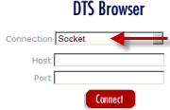

Change the default “Socket” connection to “SQL Server Microsoft” and then fill out the screen as follows:

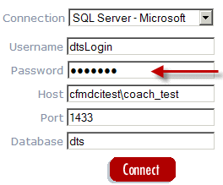

Use “a091001” for the password, click Connect, Accept the “Content Licenses” as shown, and you should get to a screen that looks something like this:

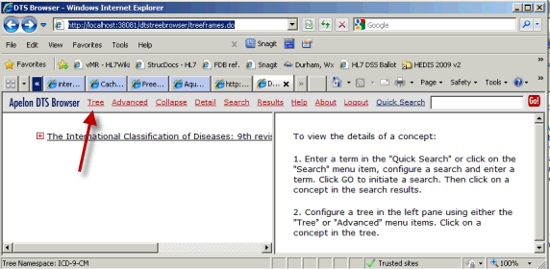

Click on the various links where the red arrow points above (click on “tree” to see the list of all the vocabularies that are loaded)

Testing and Running Apelon DTS 3.5 Editor

You can only run this locally (no web UI)

choose it from the start menu at Apelon | DTS 3.5 | Apelon DTS Editor

You will get this screen (maximize it for best utility)

